Sprinkle Irrigation Controller

* Application of Fuzzy Logic for Sprinkler Controller in Drip Irrigation.
* Controlling how long a sprinkler should function given the current Temperature and Humidity.
* Inputs:

1. Temperature: In Degree Celsius.
2. Humidity: In Percentage(%).

* Output:

Sprinkler Duration: In Minutes.

* Implementation of code for the application…
* pip install scikit-fuzzy.

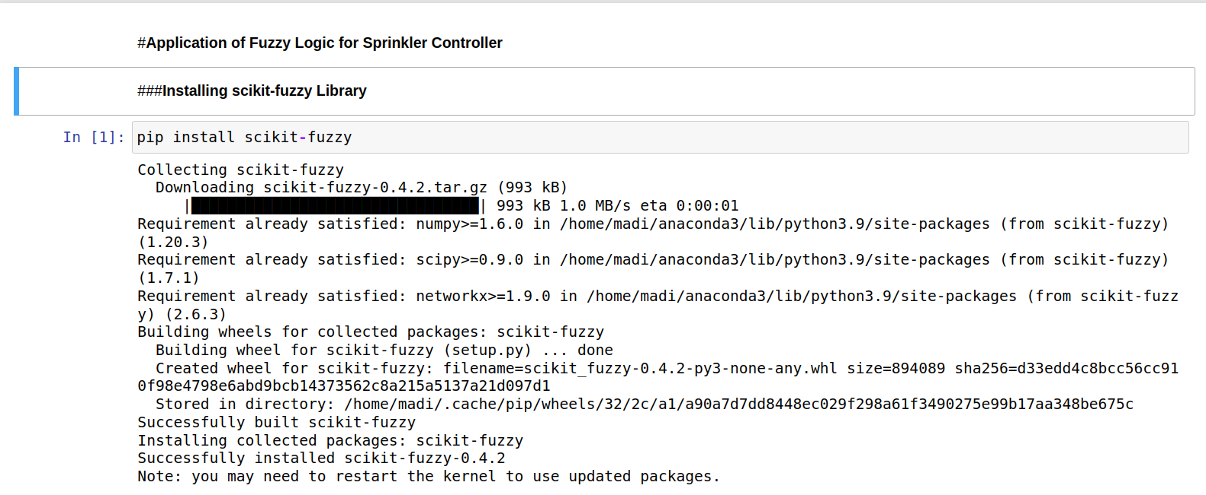

* import numpy as np

import skfuzzy as fuzz

from skfuzzy import control as ctrl

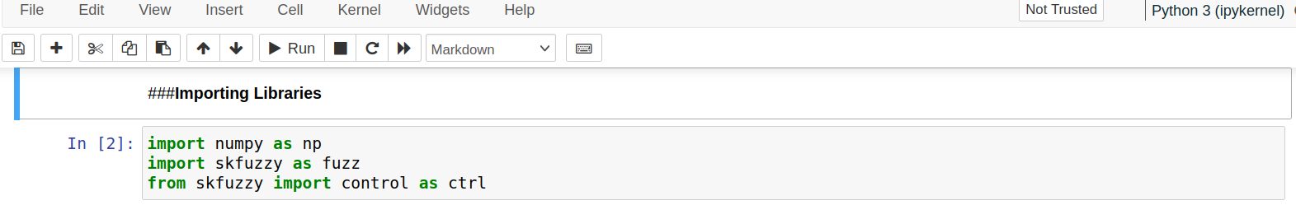

* HUMIDITY = 'humidity'

SPRINKLER_DURATION = 'sprinkler_duration'

TEMPRATURE = 'temperature'

# Temperature's fuzzy linguistics

COLD = 'Cold'

COOL = 'Cool'

NORMAL = 'Normal'

WARM = 'Warm'

HOT = 'Hot'

# Humidity's fuzzy linguistics

DRY = 'Dry'

MOIST = 'Moist'

WET = 'Wet'

# Sprinkler duration's fuzzy linguistics

SHORT = 'Short'

MEDIUM = 'Medium'

LONG = 'Long'

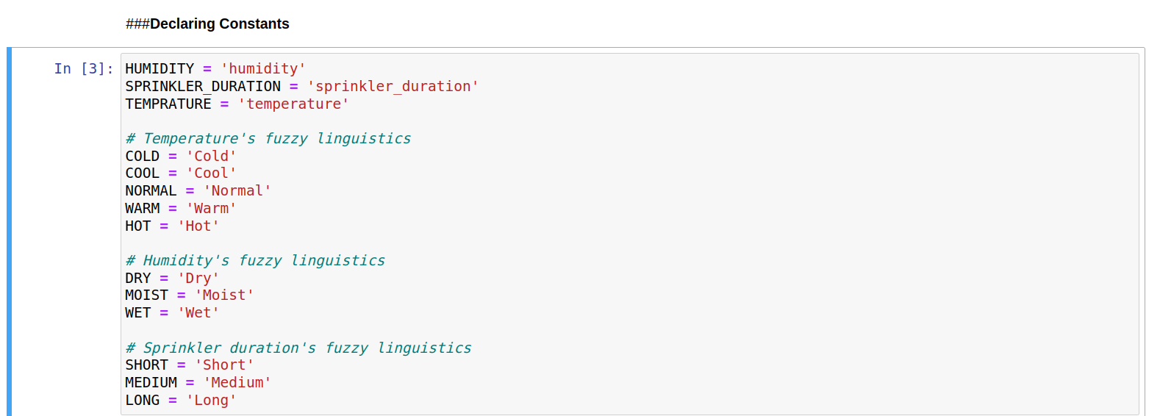

* temperature = ctrl.Antecedent(np.arange(-10,55,5), TEMPRATURE)

humidity = ctrl.Antecedent(np.arange(0,105,5), HUMIDITY)

sprinkler_duration = ctrl.Consequent(np.arange(0,105,5), SPRINKLER_DURATION)

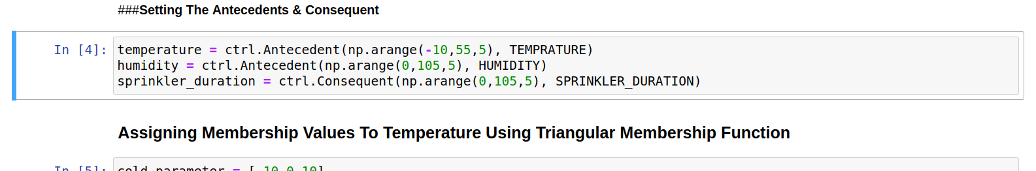

* cold_parameter = [-10,0,10]

cool_parameter = [0,10,20]

normal_parameter = [10,20,30]

warm_parameter = [20,30,40]

hot_parameter = [30,40,50]

temperature[COLD] = fuzz.trimf(temperature.universe, cold_parameter)

temperature[COOL] = fuzz.trimf(temperature.universe, cool_parameter)

temperature[NORMAL] = fuzz.trimf(temperature.universe, normal_parameter)

temperature[WARM] = fuzz.trimf(temperature.universe, warm_parameter)

temperature[HOT] = fuzz.trimf(temperature.universe, hot_parameter)

temperature.view()

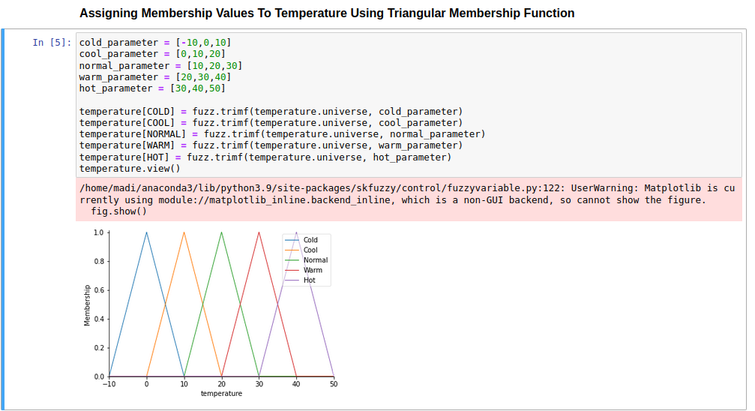

* dry_parameter = [0,25,50]

moist_parameter = [25,50,75]

wet_parameter = [50,75,100]

humidity[DRY] = fuzz.trimf(humidity.universe, dry_parameter)

humidity[MOIST] = fuzz.trimf(humidity.universe, moist_parameter)

humidity[WET] = fuzz.trimf(humidity.universe, wet_parameter)

humidity.view()

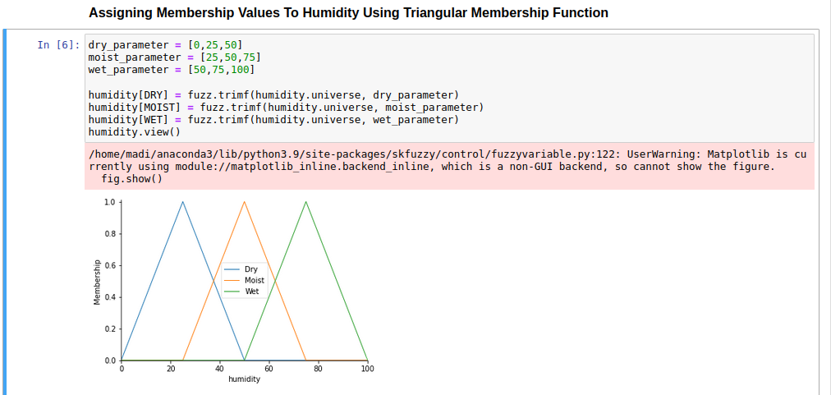

* short_parameter = [0,25,50]

medium_parameter = [25,50,75]

long_parameter = [50,75,100]

sprinkler_duration[SHORT] = fuzz.trimf(sprinkler_duration.universe, short_parameter)

prinkler_duration[MEDIUM] = fuzz.trimf(sprinkler_duration.universe, medium_parameter)

sprinkler_duration[LONG] = fuzz.trimf(sprinkler_duration.universe, long_parameter)

sprinkler_duration.view()

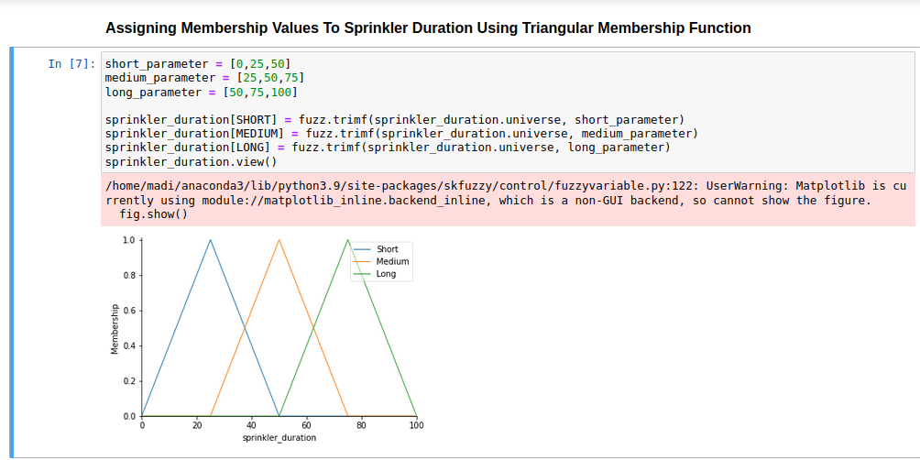

* rule1 = ctrl.Rule(humidity[DRY] & temperature[COLD], sprinkler_duration[SHORT])

rule2 = ctrl.Rule(humidity[DRY] & temperature[COOL], sprinkler_duration[SHORT])

rule3 = ctrl.Rule(humidity[DRY] & temperature[NORMAL], sprinkler_duration[MEDIUM])

rule4 = ctrl.Rule(humidity[DRY] & temperature[WARM], sprinkler_duration[LONG])

rule5 = ctrl.Rule(humidity[DRY] & temperature[HOT], sprinkler_duration[LONG])

rule6 = ctrl.Rule(humidity[MOIST] & temperature[COLD], sprinkler_duration[SHORT])

rule7 = ctrl.Rule(humidity[MOIST] & temperature[COOL], sprinkler_duration[SHORT])

rule8 = ctrl.Rule(humidity[MOIST] & temperature[NORMAL], sprinkler_duration[MEDIUM])

rule9 = ctrl.Rule(humidity[MOIST] & temperature[WARM], sprinkler_duration[MEDIUM])

rule10 = ctrl.Rule(humidity[MOIST] & temperature[HOT], sprinkler_duration[LONG])

rule11 = ctrl.Rule(humidity[WET] & temperature[COLD], sprinkler_duration[SHORT])

rule12 = ctrl.Rule(humidity[WET] & temperature[COOL], sprinkler_duration[SHORT])

rule13 = ctrl.Rule(humidity[WET] & temperature[NORMAL], sprinkler_duration[SHORT])

rule14 = ctrl.Rule(humidity[WET] & temperature[WARM], sprinkler_duration[MEDIUM])

rule15 = ctrl.Rule(humidity[WET] & temperature[HOT], sprinkler_duration[LONG])

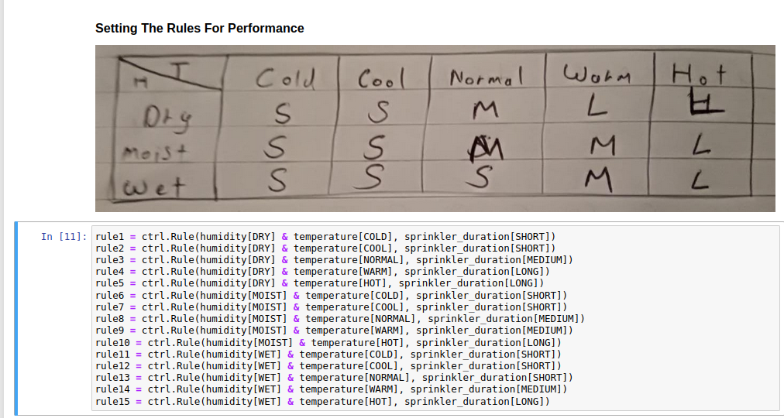

* rule_list = [

rule1, rule2, rule3, rule4, rule5,

rule6, rule7, rule8, rule9, rule10,

rule11, rule12, rule13, rule14, rule15

]

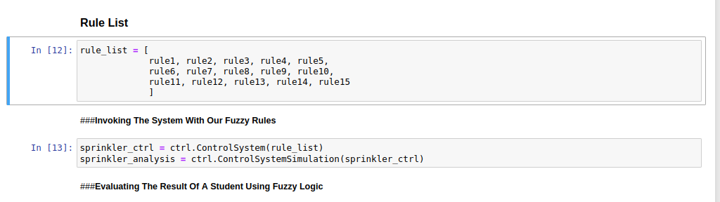

* sprinkler_ctrl = ctrl.ControlSystem(rule_list)

sprinkler_analysis = ctrl.ControlSystemSimulation(sprinkler_ctrl)

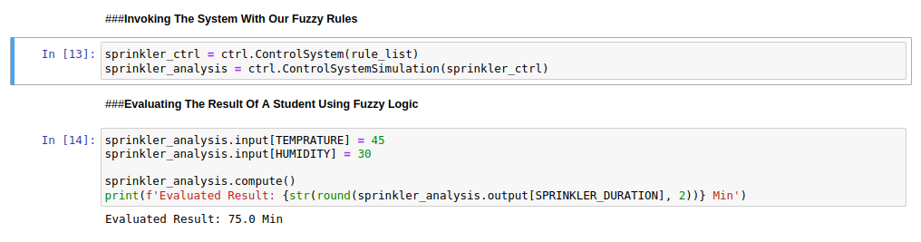

* sprinkler_analysis.input[TEMPRATURE] = 45

sprinkler_analysis.input[HUMIDITY] = 30

sprinkler_analysis.compute()

print(f'Evaluated Result: {str(round(sprinkler_analysis.output[SPRINKLER_DURATION], 2))} Min')

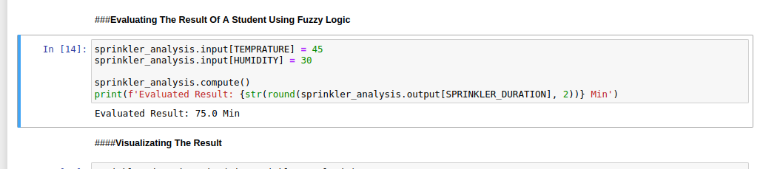

* sprinkler_duration.view(sim=sprinkler_analysis)

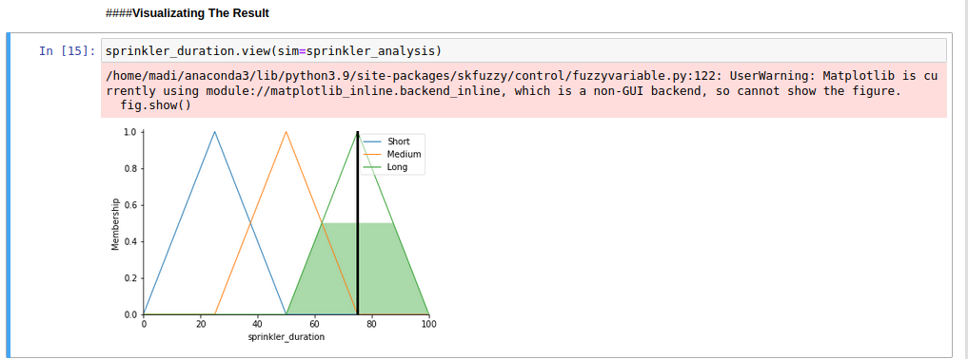

* Reference : <https://github.com/Ashley-J-George/Sprinkle_Irrigation_Controller>
* Name : Ramah Hashem madi.